- Results from B-Tree scan (scan type – bitmap index scan) and BRIN scan (Parallel Seq scan)

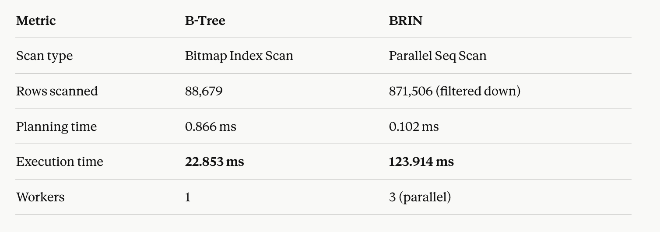

B-Tree scan execution time was less.

- On the fly calculation and using materialized views
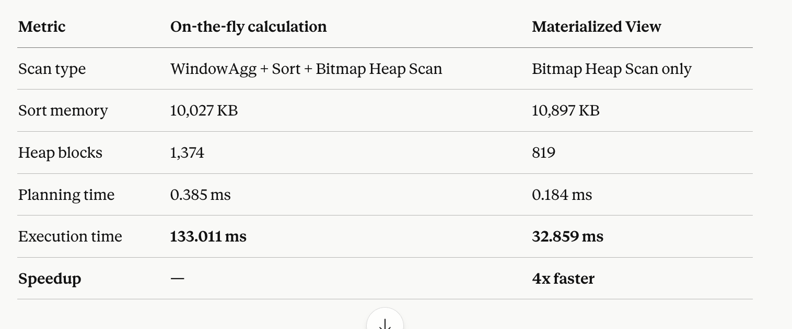

Querying TSLA's SMA-20 on the fly requires PostgreSQL to perform a WindowAgg calculation across 111,277 rows, sort them, and scan 1,374 heap blocks — taking 133ms. The materialized view eliminates the WindowAgg entirely, reduces heap blocks to 819, and returns the same result in 33ms — a 4x speedup. For a live trading engine making hundreds of queries per second, this difference is critical.

- Sequential scan vs covering index

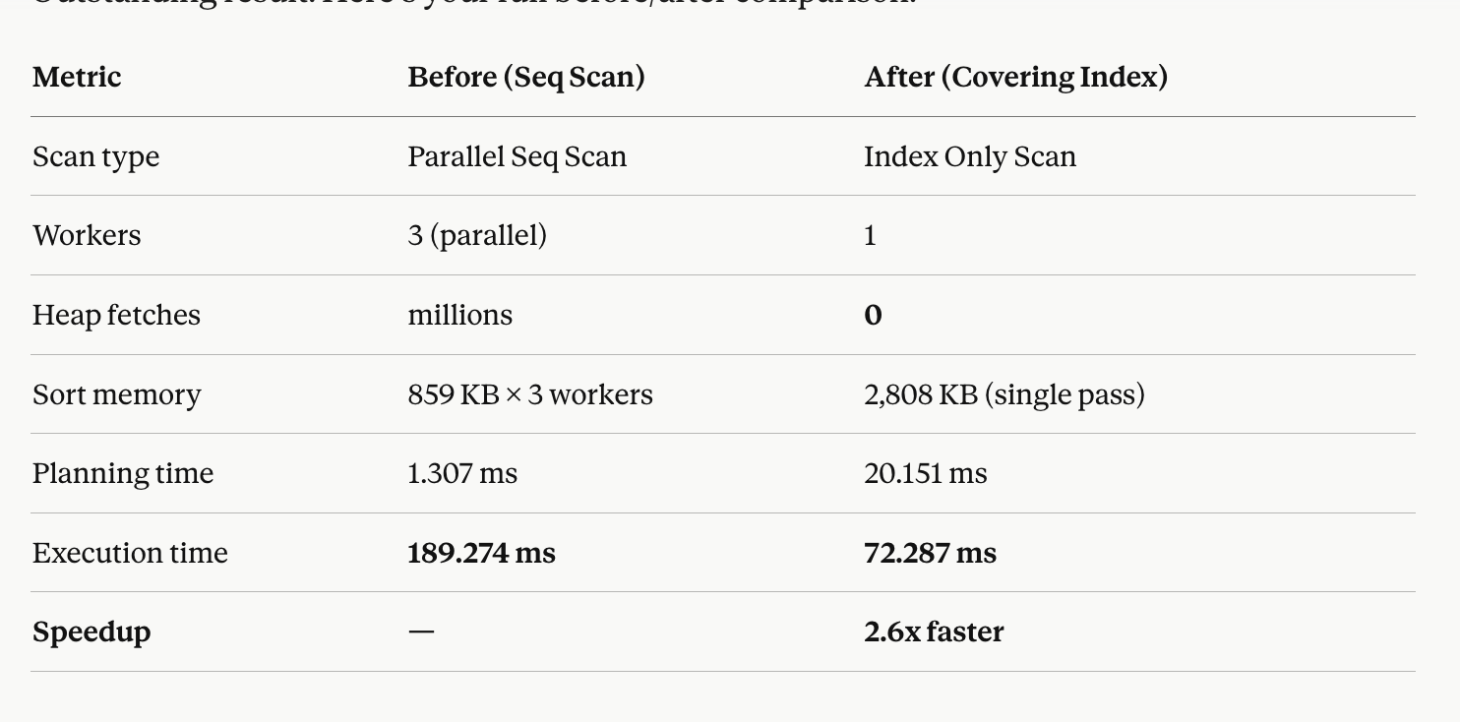

Before the covering index, PostgreSQL spawned 3 parallel workers to brute-force scan 2.6 million rows across fact_market_data. After adding a covering index with INCLUDE (high, low, close, volume), PostgreSQL switched to an Index Only Scan with 0 heap fetches — meaning it never touched the actual table at all. All data was served directly from the index. Execution time dropped from 189ms to 72ms, a 2.6x speedup.

- pg_stat_statements did not work for permissions reason. Instead used
pg_stat_activity

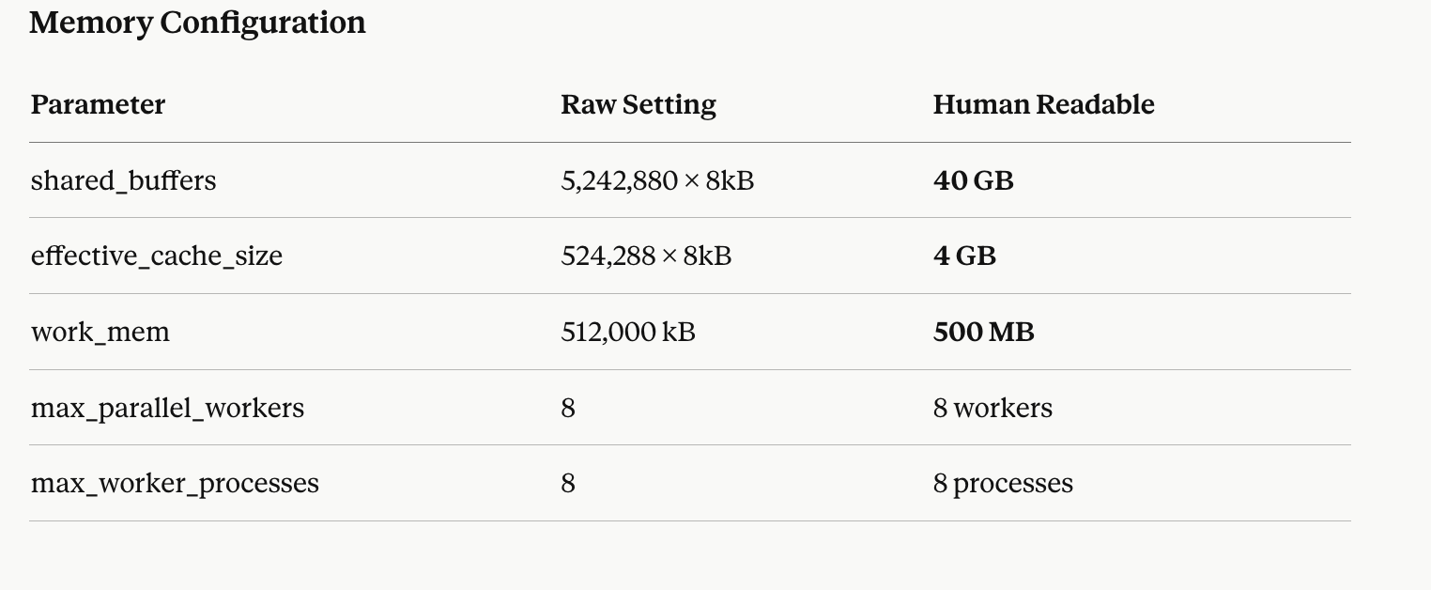
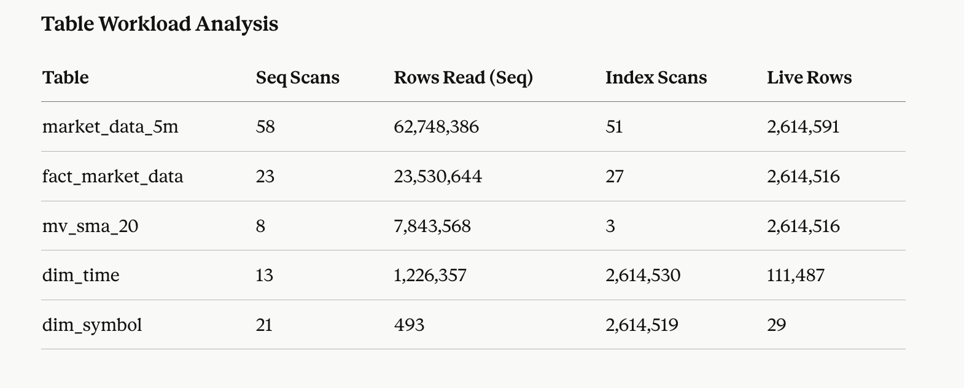

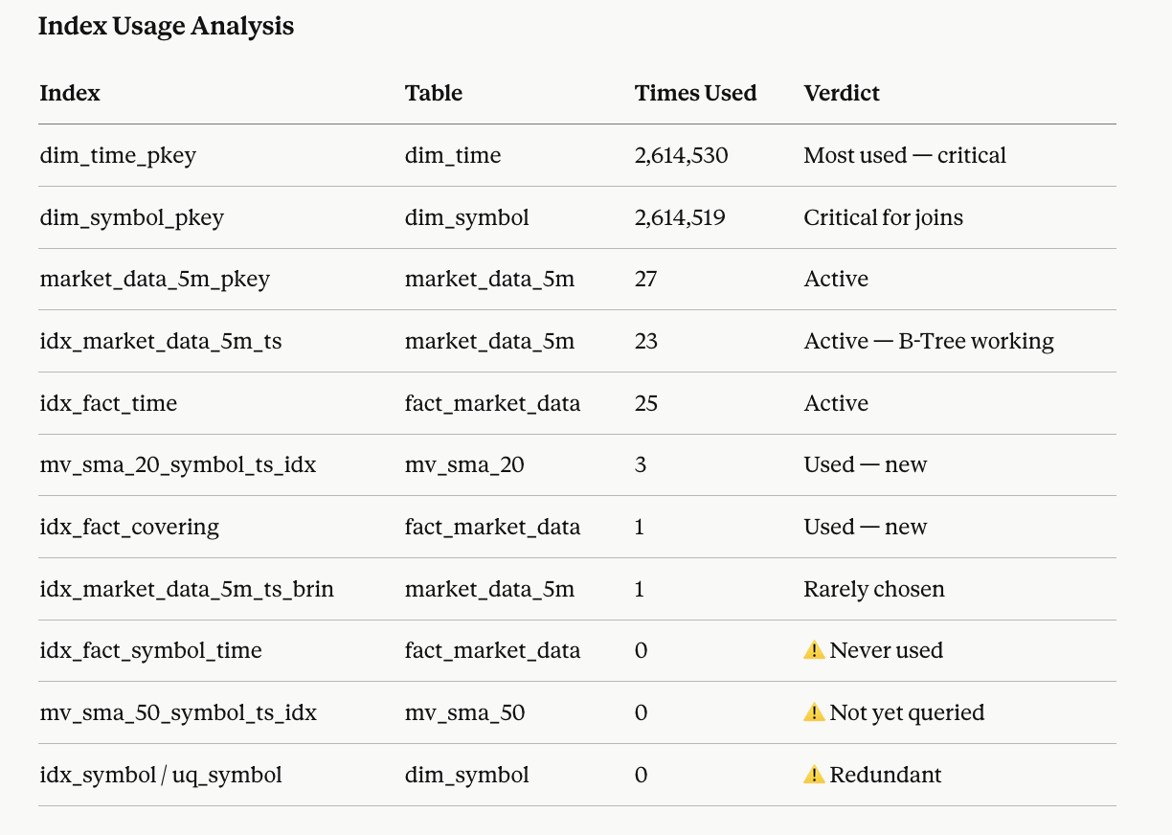

- Partitioned tables with no of rows
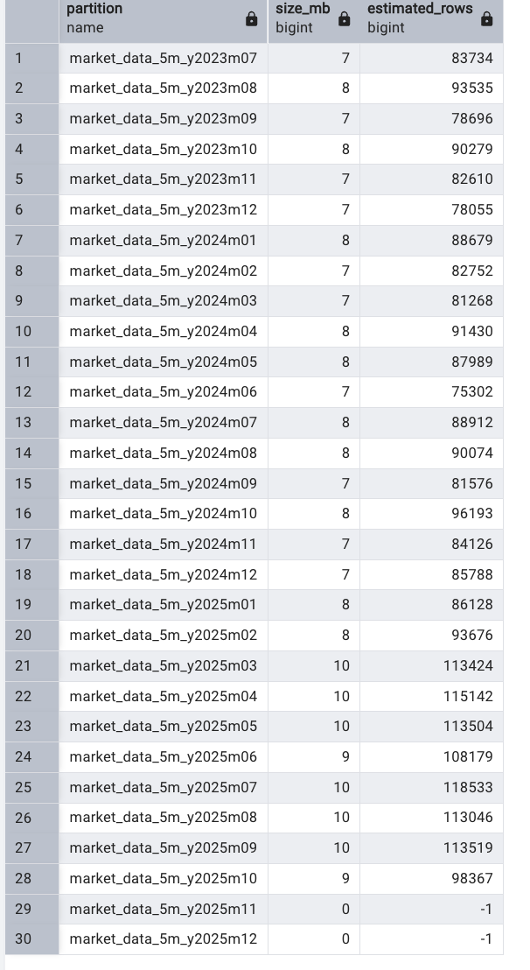

- Results that were analyzed from all the queries ran. Summary of results

